NOTE ON ADA: BEARDSLEY’S DORIC COLUMN?

‘Oh, Van, how lovely of you,’ said Lucette, slowly entering her room, with her bemused eyes scanning the fascinating flyleaf, his name on it, his bold flourish, and his own wonderful drawings in ink — a black aster (evolved from a blot), a doric column (disguising a more ribald design), a delicate leafless tree (as seen from a classroom window), and several profiles of boys (Cheshcat, Zogdog, Fancytart, and Ada-like Van himself). ADA I-23

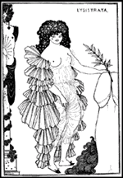

Aubrey Beardsley frontispiece for an 1898 edition of Lysistrata.

“Doric,” indeed. Although there is no pressing reason to think Van (or VN) had this image in mind, Beardsley’s work was well-known in Petersburg art circles of the Silver Age. And then there is Beardsley College in Lolita.

