Nabokov’s verbal descriptions of Ada are the most fully developed in the long novel. These descriptions begin with the twelve-yesr-old Ada (I-9) and follow her through the years until old age. Unlike Lucette who is assigned several very specific visual prototypes, Ada’s pictorial equivalents remain unspecified. They are nonetheless present even if at an almost subliminal level. Nabokov spoke freely of his predilection for creating fictive characters’ images from paintings. In “Solus Rex,” written in the winter of 1939-40, he describes life in the royal court of a remote northern kingdom. The central figure, Crown Prince Adulf, is a frivolous homosexual playboy. Near forty, he is described by Nabokov: “We have before us a well-fed, easy-going fellow, with a stout neck, a broad pelvis, a big-cheeked, evenly pink face, and fine bulging eyes. His nasty little mustache, resembling a pair of blue-black feathers, somehow did not match his fat lips, which always looked greasy…..His dark, thick, unpleasantly smelling and also greasy hair lent a foppish something … to his solidly planted head” (191-92). Nabokov’s 1973 introductory remarks to the English translation of “Ultima Thule” and “Solus Rex,” yield the man behind the description: “Prince Adulf, whose physical aspect I had imagined, for some reason, as resembling that of S. P. Diaghilev (1872-1929), remains one of my favorite characters in the private museum of stuffed people that every grateful writer has somewhere on the premises" (148).

The most famous image of the impresario of the Ballets Russes is by Valentin Serov (1865-1911) who contributed both to Diaghilev’s journal Mir iskusstvo (The World of Art) and to the scenic designs of the Ballets Russes. (Sergey Nabokov, Vladimir’s homosexual younger brother, reportedly attended the Diaghilev openings in Paris and was on the fringes of Diaghilev’s circle for some years.) Nabokov’s Prince Adulf indeed bears a marked resemblance to Diaghilev.

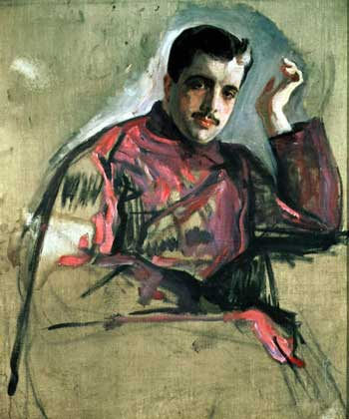

Neither Diaghilev or Prince Adulf figure in Ada, although the novel has a homoerotic subtheme. It is Diaghilev’s portraitist and collaborator, Valentin Serov (1865-1911), who may have supplied Nabokov with a visual prototype for Ada. Valentin Serov’s portraits of Russia’s social and artistic elite are among the highlights of Russia’s “Silver Age.” Russian Nabokov scholar and Ada translator Alexey Sklyarenko was the first to note that one of Serov’s “family portraits” resembles the fictional Ada, as does the picture’s setting on a country estate.

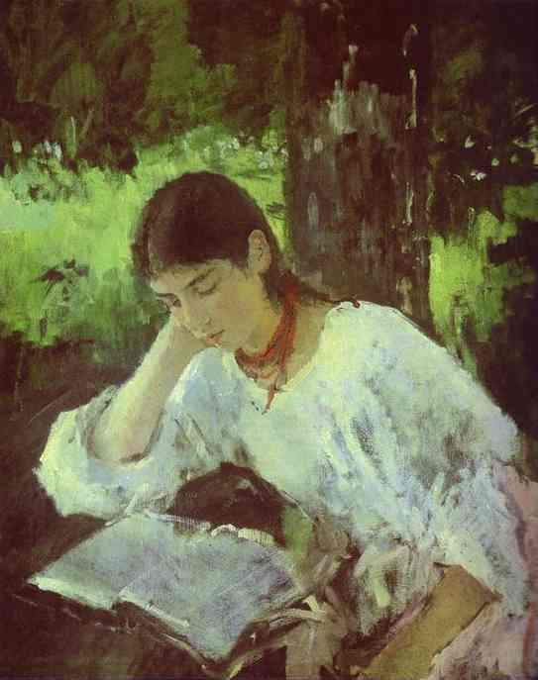

While resemblance is not proof and the Ardis-like setting could be almost anywhere, it is not without interest that the girl, a cousin of Serov, is named Adelaida Simonovich, born, like Ada, in 1872. Adelaida is a fairly rare Russian first name and is often shortened to “Ada,” although Serov’s cousin was nicknamed “Lyalya.” The 1889 portrait hangs in the Russian Museum in Nabokov’s St. Petersburg. Sklyarenko (in a NABOKV-L e-mail of December 8, 2003 further notes that:

she and her sister Nadezhda were married to the two brothers Derviz (or, more correctly, von Doerviz), Valerian and Vladimir, respectively. Valerian was a mathematician, and Vladimir, a painter, the friend of Vrubel and Serov. ... It remains to add that the Nabokovs could have known the von Doerviz family who lived in a palazzo on the English quay not far from the Nabokov house on Morskaya street directly or through mutual friends. The same can be said of the Nabokovs' possible acquaintance with Serov.

Sklyarenko goes on to remark that “half a century before, in the reign of Alexander I, such "cross-marriages" between a pair of brothers and a pair of sisters (or between two pairs of siblings) were prohibited by law as incestuous.” Incest is, of course, one of Ada’s major themes. Perhaps more to the point is an account by Nabokov’s close friend Vladislav Khodasevich describing a young poet’s (illegal) marriage to the younger sister of his brother's wife, resulting in the ruin of all concerned. "The Life of Vasily Travnikov" purported to be the discovery of a forgotten poet of genius but was in fact a hoax at the expense of Khodasevich’s Paris colleagues who enthusiastically greeted his discovery. Nabokov attended the Paris literary soiree where
Khodasevich first read his fable and Sirin read some of his own short stories.

There is, so far as I can discover, no direct reference to Serov or his Adelaida portrait in ADA. Nabokov was certainly familiar with Serov’s works. The young Nabokov was home tutored in drawing by the well-known Mstislav Dobuzhinski, Serov’s colleague in the Petersburg World of Art scene. Although none of Serov’s works are found in the incomplete records of the Nabokov family’s art holdings, his paintings and portraits were very popular among their circle and his work was widely displayed in Petersburg museums and galleries.
Valentin Serov is mentioned only once in Nabokov’s Russian fiction. In the 1934 story “A Russian Beauty” (Krasavitsa) the heroine decorates the dresser in her boarding house room with a postcard of Serov’s portrait of the Tsar” (4).

It is only after Ada, that Serov’s name begins to figure in Nabokov’s prose. In the 1974 Look at the Harlequins!, the pseudo-Nabokov protagonist, Vadim Vadimovich, brings Iris, his new bride, to meet his mysterious benefactor Count Starov.

Count Starov "chewed his lips," as old men are wont to do in Russian novels. Miss Vrode-Vorodin, the elderly cousin who kept house for him, made a timely entrance and led Iris to an adjacent alcove (illuminated by a resplendent portrait by Serov, 1896, of the notorious beauty, Mme. De Blagidze, in Caucasian costume) for a nice cup of tea. The Count wished to talk business with me and had only ten minutes "before his injection."
What was my wife's maiden name?
I told him. He thought it over and shook his head. What was her mother's name?
I told him that, too. Same reaction (49).

Serov did many high-society portraits but none fit the description of a notorious beauty in “Caucasian costume.” The fictional Mme. Blagidze is the mother of one or more Count Starov’s children who apparently know nothing of their parentage. The reader eventually realizes that Count Starov is father to both Vadim and Iris (and a number of other characters, including Vadim’s subsequent wives).

Vadim has a daughter “Bel” whom her mother, Annette, takes when she abandons the girl’s father. The mother dies when Bel is eleven and the girl comes to live with Vadim.

Scarcely a month after her arrival I was already at a loss to understand how she could have struck me as "plain." Another month elapsed and the elfin line of her nose and upper lip in profile came as an "expected revelation"-- to use a formula I have applied to certain prosodic miracles in Blake and Blok. Because of the contrast between her pale-gray iris and very black lashes, her eyes seemed rimmed with kohl. Her hollowed cheek and long neck were pure Annette, but her fair hair, which she wore rather short, gave off a richer sheen as if the tawny strands were mixed with gold-olive ones in thick straight stripes of alternate shades. All this is easily described and this also goes for the regular striation of bright bloom along the outside of forearm and leg, which, in fact, smacks of self-plagiarism, for I had given it both to Tamara and Esmeralda, not counting several incidental lassies in my short stories (see for example page 537 of the Exile from Mayda collection, Goodminton, New York, 1947) [168-69].

The reader will notice that Vadim’s verbal description of Bel does not fit Ada. Bel is a composite. (Incidentally some of her features such as her hair color and long neck derive from her mother, Annettte, whose appearance is explicitly based on Botticelli’s Venus.) The narrator, Vadim, realizes the inadequacy of his purely verbal description and, as in the case of Prince Adulf/Diaghilev, reverts to a pictorial prototype in the following passage:

The general type and bone structure of her pubescent radiance
cannot be treated, however, with a crack player's brio and chalk-biting serve. I am reduced--a sad confession!--to something I have also used before, and even in this book--the well-known method of degrading one species of art by appealing to another. I am thinking of Serov's Five-petaled Lilac, oil, which depicts a tawny-haired girl of twelve or so sitting at a sun-flecked table and manipulating a raceme of lilac in search of that lucky token. The girl is no other than Ada Bredow, a first cousin of mine whom I flirted with disgracefully that very summer, the sun of which ocellates the garden table and her bare arms. What hack reviewers of fiction call "human interest" will now overwhelm my reader, the gentle tourist, when
he visits the Hermitage Museum in Leningrad, where I have seen with my own rheumy eyes, on a visit to Sovietland a few years ago, that picture which belonged to Ada's grandmother before being handed over to the People by a dedicated purloiner. I believe that this enchanting little girl was the model of my partner in a recurrent dream of mine with a stretch of parquetry between two beds in a makeshift demonic guest room. Bel's resemblance to her--same cheekbones, same chin, same knobby wrists, same tender flower—can be only alluded to, not actually listed (IV-3).

As with the pseudo-Serov Mme Blagidze portrait, there is no Serov painting that exactly fits the above description of Ada (Bredow) but the prototype for Serov’s Five-Petaled Lilac is obviously his Girl with Peaches. Portrait of Vera Mamontova (1887), now in Moscow’s Tretyakov Gallery.
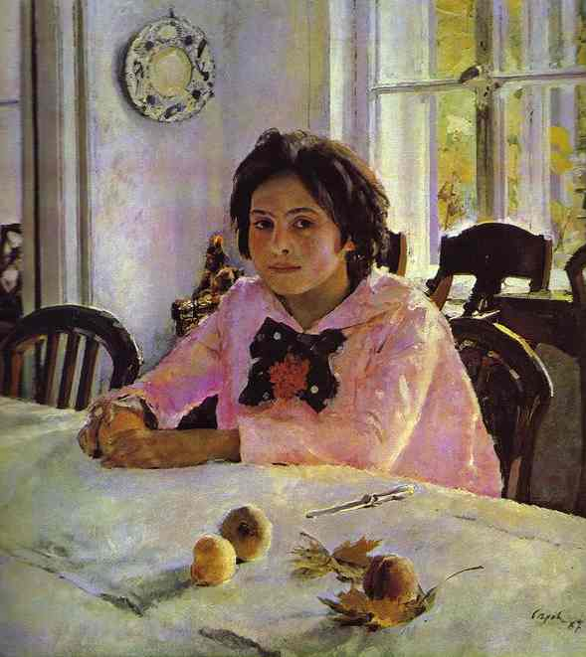

Nabokov appears to have provided (partial) pictorial representations of Ada at approximately twelve and sixteen, corresponding to the magical Ardis summers of 1884 and 1886. The “fictionalizations” of the Serov portraits is perhaps to be explained by the situation of the narrators in the two novels. In both books there are two worlds, closely akin, but differing in some respects from its counterpart. Just as the fictional writer Vadim Vadimovich in his delusional world produces a series of novels that are similar to, but different from those of Vladimir Vladimirovich Nabokov and Van in his memoir creates a semi-mythical world echoing our world, the almost-Serov portraits depict Antiterra’s Ada at two stages of her life. Vadim reinforces such a possibility: “That avenue of statues and lilacs where Ada and I drew our first circles on the dappled sand was visualized and re-created by an artist of lasting worth. The hideous suspicion that even Ardis, my most private book, soaked in reality, saturated with sun flecks, might be an unconscious imitation of another's unearthly art, that suspicion might come later…” (VI-2, 234).

It is only by backcasting from Look at the Harlequins! to
Ada that the underlying imagery from Serov appears. Ending on a note of caution…, just as Nabokov’s portraits by Serov are not authentic but rather “in the style of,” his backcasting of Serov’s work as a source of Ada’s image might be taken with a grain of salt.

