The Gift

First English edition, G.P. Putnam’s Sons
New York, 27 May 68

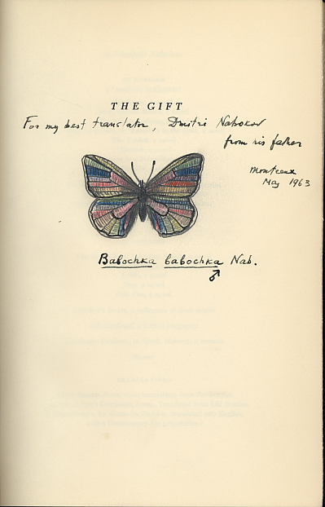

Invented but scientifically plausible genus and species, Babochka babochka (“butterfly” in Russian), with its taxonomically placed and abbreviated discoverer, and the male designation.

