Transparent things
Cose trasparenti, Italian edition
Mondadori 1975

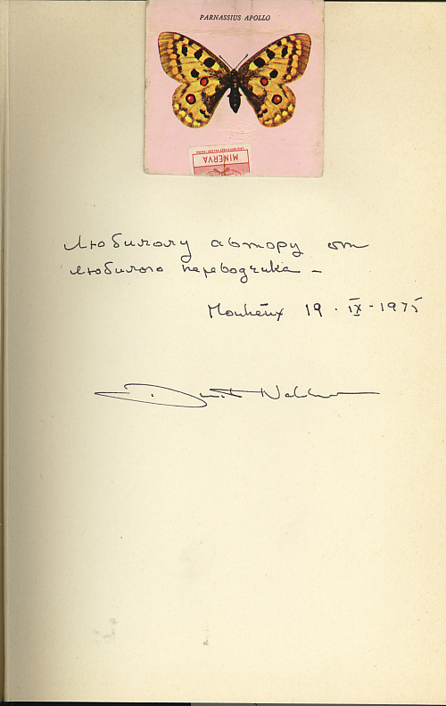

DN had the rare pleasure of inscribing a book to his father:
“To beloved author from beloved translator.” (Russ.)

Unable to compete with VN’s graphic and entomological virtuosity, DN elected to affix a very well done Parnassius Apollo from an Italian matchbook cover.

